Creational Patterns
# Source: AI Source: Provided by: [Data Path: Persons Table -> ID Column: 1, Name_En Column: Motasem Essam] -> From: [ChatGPT] on [1/23/2026]
Creational Patterns are design patterns that deal with object creation mechanisms, trying to create objects in a controlled and flexible manner.
👉 Think of them as blueprints for building objects, allowing you to abstract and manage instantiation.

🔑 Key Points
# Source: AI Source: Provided by: [Data Path: Persons Table -> ID Column: 1, Name_En Column: Motasem Essam] -> From: [ChatGPT] on [1/23/2026]
• Control how objects are created
• Promote flexibility, decoupling, and reuse
• Avoid tight coupling between client and concrete classes
• Useful when object creation is complex or varies at runtime

🏗️ Types of Creational Patterns

1️⃣ Singleton Pattern
# Source: AI Source: Provided by: [Data Path: Persons Table -> ID Column: 1, Name_En Column: Motasem Essam] -> From: [ChatGPT] on [1/23/2026]
Ensures a class has only one instance and provides a global point of access.
Use case: Logging, configuration managers, caching.
Example:
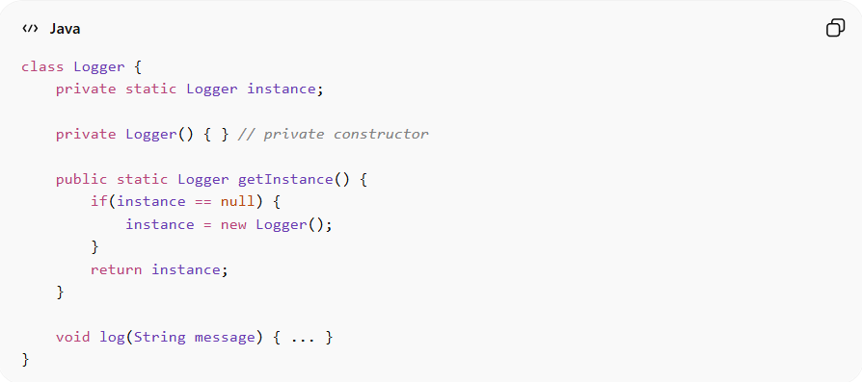
class Logger {
private static Logger instance;

private Logger() { } // private constructor

public static Logger getInstance() {
if(instance == null) {
instance = new Logger();
}
return instance;
}

void log(String message) { ... }
}
Advantages:
• Controlled access to single instance
• Saves memory and resources
• Ensures consistent behavior
Disadvantages:
• Can introduce global state, making testing harder
• Hard to extend due to private constructor
• May cause tight coupling if overused

2️⃣ Factory Method Pattern
# Source: AI Source: Provided by: [Data Path: Persons Table -> ID Column: 1, Name_En Column: Motasem Essam] -> From: [ChatGPT] on [1/23/2026]
Defines an interface for creating an object, but lets subclasses decide which class to instantiate.
Use case: Creating objects without specifying the exact class, e.g., GUI components for different OS.
Example:
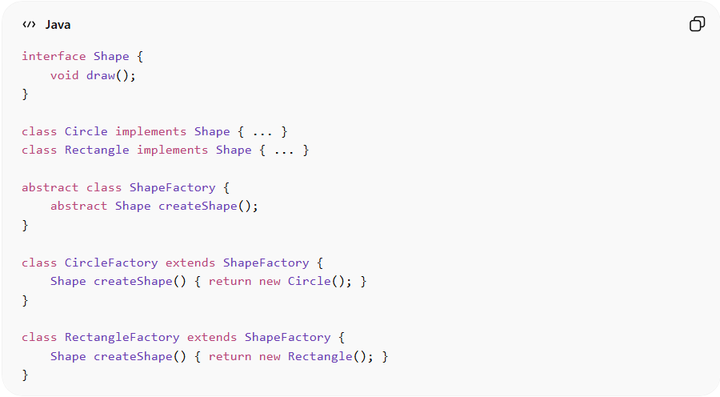
interface Shape {
void draw();
}

class Circle implements Shape { ... }
class Rectangle implements Shape { ... }

abstract class ShapeFactory {
abstract Shape createShape();
}

class CircleFactory extends ShapeFactory {
Shape createShape() { return new Circle(); }
}

class RectangleFactory extends ShapeFactory {
Shape createShape() { return new Rectangle(); }
}
Advantages:
• Decouples client code from concrete classes
• Promotes extensibility
• Simplifies adding new types
Disadvantages:
• Can lead to many small subclasses
• Slightly more complex structure
• Client must know which factory to use

3️⃣ Abstract Factory Pattern
# Source: AI Source: Provided by: [Data Path: Persons Table -> ID Column: 1, Name_En Column: Motasem Essam] -> From: [ChatGPT] on [1/23/2026]
Provides an interface to create families of related objects without specifying their concrete classes.
Use case: UI toolkit supporting multiple themes (Light/Dark) or platforms.
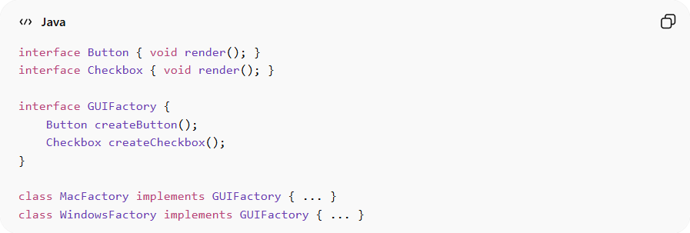
Example:
interface Button { void render(); }
interface Checkbox { void render(); }

interface GUIFactory {
Button createButton();
Checkbox createCheckbox();
}

class MacFactory implements GUIFactory { ... }
class WindowsFactory implements GUIFactory { ... }
Advantages:
• Enforces consistency among related objects
• Decouples client code from implementations
• Easy to switch entire families of objects
Disadvantages:
• Complex structure → many interfaces and classes
• Harder to extend with new object types
• Overkill for small systems

4️⃣ Builder Pattern
# Source: AI Source: Provided by: [Data Path: Persons Table -> ID Column: 1, Name_En Column: Motasem Essam] -> From: [ChatGPT] on [1/23/2026]
Separates the construction of a complex object from its representation, allowing the same construction process to create different representations.
Use case: Creating complex objects like reports, vehicles, or meals step by step.
Example:
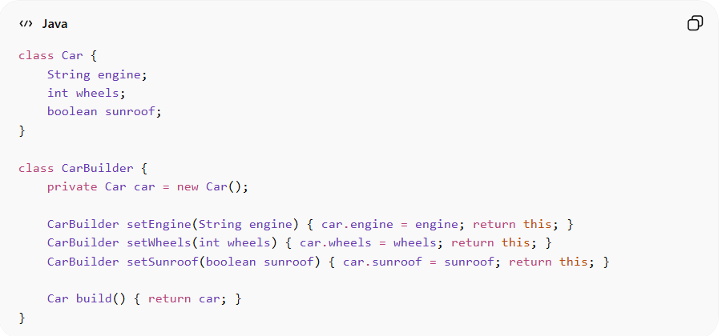
class Car {
String engine;
int wheels;
boolean sunroof;
}

class CarBuilder {
private Car car = new Car();

CarBuilder setEngine(String engine) { car.engine = engine; return this; }
CarBuilder setWheels(int wheels) { car.wheels = wheels; return this; }
CarBuilder setSunroof(boolean sunroof) { car.sunroof = sunroof; return this; }

Car build() { return car; }
}
Advantages:
• Step-by-step object creation
• Cleaner, readable code for complex objects
• Supports multiple representations
Disadvantages:
• More classes needed → adds complexity
• Overhead for simple objects
• Builder pattern can be verbose

5️⃣ Prototype Pattern
# Source: AI Source: Provided by: [Data Path: Persons Table -> ID Column: 1, Name_En Column: Motasem Essam] -> From: [ChatGPT] on [1/23/2026]
Creates new objects by cloning existing ones, rather than creating from scratch.
Use case: Copying objects with complex initialization or costly creation.
Example:
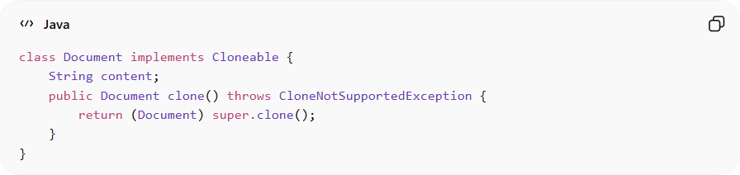
class Document implements Cloneable {
String content;
public Document clone() throws CloneNotSupportedException {
return (Document) super.clone();
}
}
Advantages:
• Reduces cost of creating objects
• Simplifies copying of complex objects
• Supports dynamic object configuration
Disadvantages:
• Cloning can be tricky for deep copy objects
• Can be error-prone if not implemented carefully
• Requires careful handling of mutable fields

⚡ When to Apply Creational Patterns
# Source: AI Source: Provided by: [Data Path: Persons Table -> ID Column: 1, Name_En Column: Motasem Essam] -> From: [ChatGPT] on [1/23/2026]
• Object creation is complex or requires multiple steps
• System must be flexible to change the type of objects at runtime
• You want to decouple client code from concrete classes
• Useful in frameworks, libraries, and enterprise systems

